**gd'gf k|Zg kq**

**sIfM @ प्रथम त्रैमासिक परीक्षा—@)*@**

**D-**

**ljifoM ;]/f]km]/f]**

**!= Hff]8f ldnfpg'xf];\ M -$_**

l5d]sL z/L/sf] tfks|d ;fdfGo eGbf a9L x'g'

;xof]u jl/kl/ /x]sf] 3/df a:g]

/xg;xg ;xof]u ug]{, d¢t ug]{

**@= vfnL 7fpF eg'{xf]; M -$_**

-udL{, efG;], l;sdL{, htg_

s= xfdL __________ dlxgfdf ;'tLsf n'uf nufpFb5f}F .

v= xfdLn] cfkmgf] ;fdfgsf] __________ ug{'k5{ .

u= h;n] vfgf ksfpF5 p;nfO{ __________ elgG5 .

3= sf7sf] sfd ug]{ dflg;nfO{ __________ elgG5 .

**#= l7s a]l7s n]Vg'xf];M -$_**

s= xfd|f] b]z ljleGg hflt, wd{ / ;+:s[ltsf] ;femf km"naf/L xf] .

v= l5d]sL;Fu P]Frf]k}Frf] rNb}g .

u= z/L/ :jfYo /fVg v]n v]Ng' k5{ .

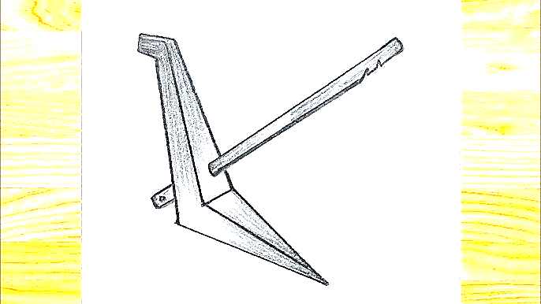3= cfkm'nfO{ k/]sf] ;d:of s;}nfO{ eGg'x'b}g\ .

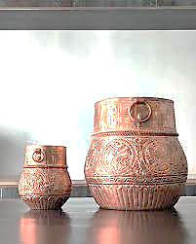**$= tnsf lrqx¿sf] gfd n]Vg'xf];\ . -$_**

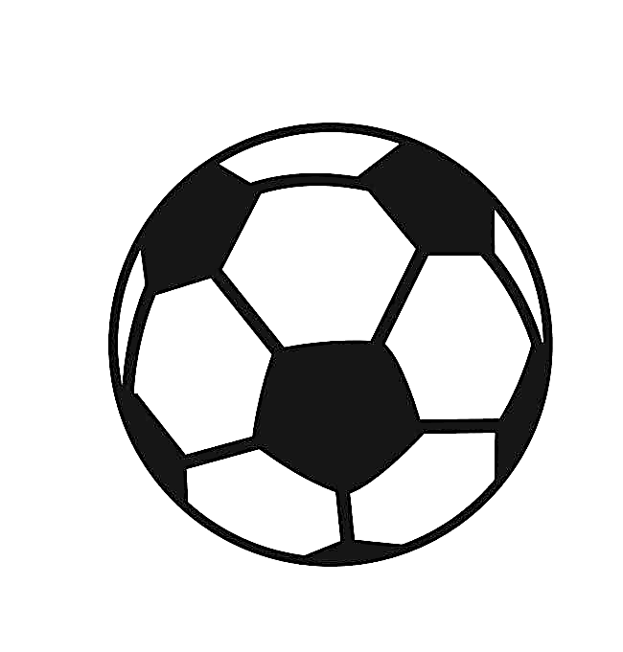

**%= tnsf] gfd n]Vg'xf];\ . -^_**

c= s'g} b'O{ cGgx¿

__________ __________

cf=s'g} b'O{ kmnkmn"x¿

__________ __________

O= s'g} b'O{ ;ª\uLtsf ;fwfx¿

__________ __________

**^= tnsf k|Zgx¿sf] pQ/ n]Vg'xf];\ . -!)_**

s= xfdL xflR5pF ubf{ jf vf]Sbf s] ug'{k5{ <

v= xfdL ;w}F s:tf] kf];fs nufpF5f}<

u= t/fh'n] s] sfd u5{<

3= ljGb'x¿ hf]8\bf s] aG5<

ª= s] xfdL kfgLlagf afFRg ;S5f}F <

**&= JolStut ;/;kmfOdf k|of]u x'g] s'g} Ps ;fdfgsf] lrq agfO gfd n]Vg'xf];\ . -$_**

**\*= udL{ / hf8f]df nufpg] n'ufsf] ;"rL tof/ ug'{xf];\ M -$_**

|  |  |
| --- | --- |
| udL{df nufpg] n'ufx¿ | hf8f]df nufpg] n'ufx¿ |
|  |  |
|  |  |
|  |  |
|  |  |

###